**Introduction:**

In this lab we had to develop, test and analyze algorithms for multiplying two matrices using the traditional Iterative method and Strassen’s algorithm for matrix multiplication.

**Approach:**

1. **Iterative Method:**

If **A** is an *n × m* matrix and **B** is an *m × p* matrix, then their product **AB** is *n × p*

In case of traditional iterative method

$${\left(AB\right)}_{ij}= \sum_{k=1}^{m}{{A }_{ik}B_{kj}}$$

where each *i, j* entry is given by multiplying the entries **Aik** (where i=1,2,…,n) by the entries **Bkj** (where j=1,2,…,p), and summing the results over k(where k=1,2,...,m)

1. **Strassen Algorithm:**

The Strassen algorithm is an algorithm for matrix multiplication. It is faster than the standard matrix multiplication algorithm and is useful in practice for large matrices.

**How to Run:**

The order, **n**, of the matrix has to be provided as an input and two matrices of **n**x**n** will be generated using random numbers.

The class “iterative_Multiplication” multiplies the matrices using the iterative method and gives the answer.

The class “matrix_Multiplication” multiplies the matrices using the iterative method and gives the answer.

**Analysis:**

1. **Iterative Method:**

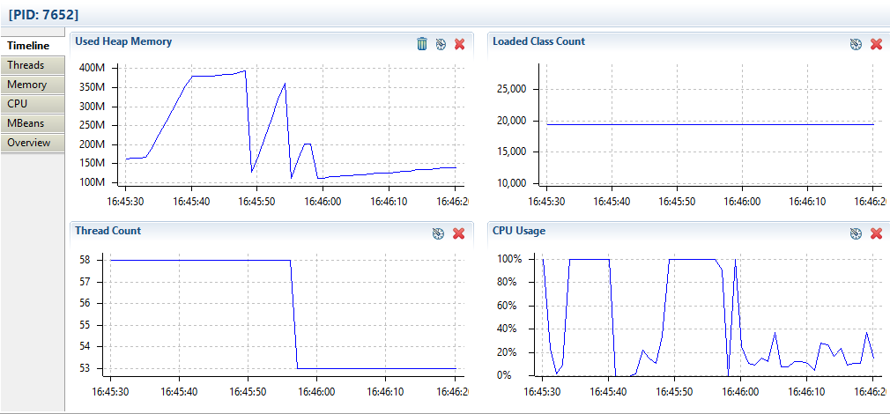

1. **Strassen Algorithm:**

